Transmission Electron microscope --- TEM
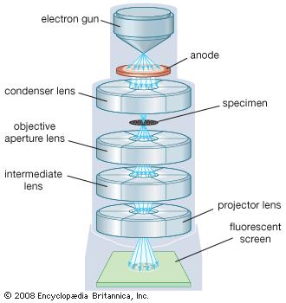

Transmission electron microscope (TEM), type of electron microscopethat has three essential systems: (1) an electron gun, which produces the electron beam, and the condenser system, which focuses the beam onto the object, (2) the image-producing system, consisting of the objective lens, movable specimen stage, and intermediate and projector lenses, which focus the electrons passing through the specimen to form a real, highly magnified image, and (3) the image-recording system, which converts the electron image into some form perceptible to the human eye. The image-recording system usually consists of a fluorescent screen for viewing and focusing the image and a digital camera for permanent records. In addition, a vacuum system, consisting of pumps and their associated gauges and valves, and power supplies are required.

The electron gun and condenser system
The source of electrons, the cathode, is a heated V-shaped tungsten filament or, in high-performance instruments, a sharply pointed rod of a material such as lanthanum hexaboride. The filament is surrounded by a control grid, sometimes called a Wehnelt cylinder, with a central aperture arranged on the axis of the column; the apex of the cathode is arranged to lie at or just above or below this aperture. The cathode and control grid are at a negative potential equal to the desired accelerating voltage and are insulated from the rest of the instrument. The final electrode of the electron gun is theanode, which takes the form of a disk with an axial hole. Electrons leave the cathode and shield, accelerate toward the anode, and, if the stabilization of the high voltage is adequate, pass through the central aperture at a constant energy. The control and alignment of the electron gun are critical in ensuring satisfactory operation.
The intensity and angular aperture of the beam are controlled by the condenser lens system between the gun and the specimen. A single lens may be used to converge the beam onto the object, but, more commonly, a double condenser is employed. In this the first lens is strong and produces a reduced image of the source, which is then imaged by the second lens onto the object. Such an arrangement is economical of space between the electron gun and the object stage and is more flexible, because the reduction in size of the image of the source (and hence the final size of illuminated area on the specimen) may be varied widely by controlling the first lens. The use of a small spot size minimizes disturbances in the specimen due to heating and irradiation.

The image-producing system
The specimen grid is carried in a small holder in a movable specimen stage. The objective lens is usually of short focal length (1–5 mm [0.04–0.2 inch]) and produces a real intermediate image that is further magnified by the projector lens or lenses. A single projector lens may provide a range of magnification of 5:1, and by the use of interchangeable pole pieces in the projector a wider range of magnifications may be obtained. Modern instruments employ two projector lenses (one called the intermediate lens) to permit a greater range of magnification and to provide a greater overall magnification without a commensurate increase in the physical length of the column of themicroscope.
For practical reasons of image stability and brightness, the microscope is often operated to give a final magnification of 1,000–250,000× on the screen. If a higher final magnification is required, it may be obtained by photographic or digital enlargement. The quality of the final image in the electron microscope depends largely upon the accuracy of the various mechanical and electrical adjustments with which the various lenses are aligned to one another and to the illuminating system. The lenses require power supplies of a high degree of stability; for the highest standard of resolution, electronic stabilization to better than one part in a million is necessary. The control of a modern electron microscope is carried out by a computer, and dedicated software is readily available.

Image recording
The electron image is monochromatic and must be made visible to the eye either by allowing the electrons to fall on a fluorescent screen fitted at the base of the microscope column or by capturing the image digitally for display on a computer monitor. Computerized images are stored in a format such as TIFF or JPEG and can be analyzed or image-processed prior to publication. The identification of specific areas of an image, or pixels with specified characteristics, allows spurious colours to be added to a monochrome image. This can be an aid to visual interpretation and teaching and can create a visually attractive picture from the raw image.

Second Notes for TEM

Principle

Electron beams are used in electron microscope to illuminate the specimen and thus creates an image. Since the wavelength o f electrons are 100,000 times shorter than visible light the electron microscopes have greater resolving power. They can achieve a resolution of 0.2nm and magnifications upto 2,000,000 x. Light microscopes show limited resolution than electron microscopes. Light microscopes have a resolution of 200nm and can magnify upto 2000x. Electron microscopes use a beam of electrons to illuminate the specimen instead of light as in light microscopy. The electron microscopes are of the following types:

- Transmission electron microscope
- scanning electron microscope
- scanning tunneling electron microscope
In transmission electron microscope (TEM), the source of illumination is a beam of electrons of very short wavelength, emitted from a tungsten filament at the top of a cylindrical column of about 2 m high. The whole optical system of the microscope is enclosed in vacuum. Air must be evacuated from the column to create a vacuum so that the collision of electrons with air molecules and hence the scattering of electrons are avoided. Along the column, at specific intervals magnetic coils are placed. Just as the light is focused by the glass lenses in a light microscope, these magnetic coils in the electron microscope focus the electron beam. The magnetic coils placed at specific intervals in the column acts as an electromagnetic condenser lense system. The specimen stained with an electron dense material and is placed in the vacuum. The electron beams are passes through the specimen and scattered by the internal structures.

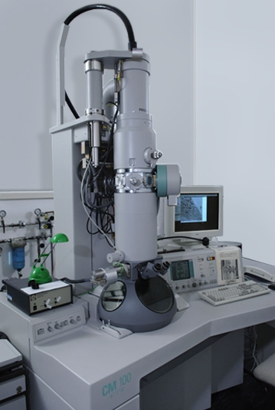
The heated filament emits electrons which are then accelerated by a voltage in the anode. A higher anode voltage will give the electrons a higher speed. Thus the electrons will have a smaller de Broglie wavelength according to the equation, λ = h/mv. The resolving power of a microscope is directly related to the wavelength of the irradiation, which used to form an image. The faster the electrons travel, the shorter their wavelength. As the wavelength is reduced, the resolution is increased. Therefore, the resolution of the microscope is increased if the accelerating voltage of the electron beam is increased.

Transmission electron microscopy involves a high voltage beam of electron emitted by a cathode and formed by magnetic lenses. The beam of electron that has been partially transmitted through the very thin specimen carries information about the structure of the specimen. The spatial variation in this information (the "image") is then magnified by a series of magnetic lenses until it is recorded by hitting a fluorescent screen, photographic plate, or light sensitive sensor like CCD (charge-coupled device) camera. The image detected by the CCD may be displayed in real time on a monitor or computer.
The TEM has the ability ability to determine the positions of atoms within materials which has made an indispensable tool for nano-technologies research and development in many fields, including heterogeneous catalysis and the development of semiconductor devices for photonics and electronics. In the life sciences, it is still mainly the specimen preparation which limits the resolution of what we can see in the electron microscope, rather than the microscope itself.
There are four parts for a transmission electron microscope:
• Electron source
• Electromagnetic lens system
• Sample holder
• Imaging system
The electron source is an electron gun which consists of a tungsten filament. This filament emits electrons when it is heated. The beam of electrons are the focused on the specimen by the condenser which consists of electromagnets called magnetic lenses. The sample holder consists of a mechanical arm which holds the specimen. The imaging system also consists of electromagnetic lens system and a screen which has a phosphorescent plate. The plate glows when hit by the electrons after passing through the specimen.

ELECTRON GUN

The function of an electron gun is to emit an intense beam of electrons into the vacuum which accelerates the between the cathode and the anode. There are two main types of electron gun: thermionic electron gun and field emission gun. The metals contain free electrons. The valence are free electrons electrons, which are loosely bound in the nucleus. Those electrons cannot escape from the metal surface . The positively charged nucleus will try to pull back the free electrons when they try to escape from the surface. Hence the electrons have to overcome the potential barrier in order to escape from the surface of the metals. The energy required to overcome this potential barrier is called work function.

Work function, φ, is the minimum energy in electron volts required to remove an electron from the metal surface. If the electrons in metals are to be emitted from the cathode they have to overcome the work function.
Electrons are emitted from a metal by two methods:
- Thermionic emission: In this method the electrons are emitted from the metals by heating them.
- Field emission: In this method the electrons are emitted from metals, under strong electric fields.

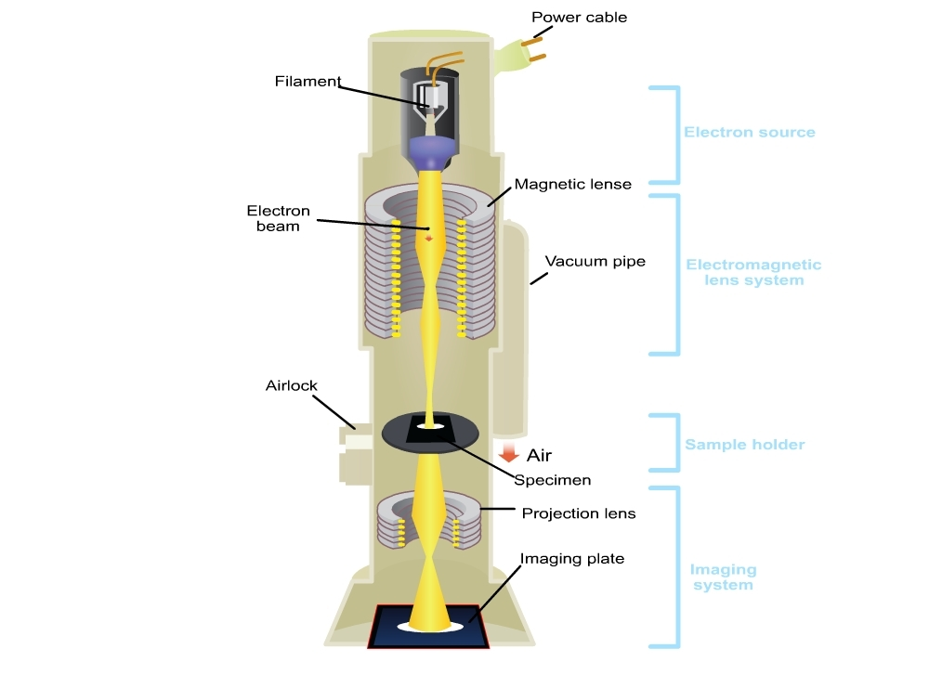
Thermionic electron gun
The filament is made from a high melting point material or low work function, in order to emit many electrons. Tungsten filament is most commonly used in thermionic electron gun. Tungsten wire used as thermionic cathodes are of 0.1-0.2mm in diameter bent like a hairpin and soldered on contacts. The wire is heated by a current of a few amperes.
Field emission electron gun

In fleld emission electron gun, a very strong electric field is used to extract electrons from a metal filament. Temperatures are lower than that needed for thermionic emission. This gives much higher source brightness than thermionic guns, but requires a very good vacuum.

SAMPLE PREPARATION
Sample preparation is important for electron microscopy. There are three main steps for sample preparation: Processing, embedding and polymerization.
Processing
This includes: fixation, rinsing, post fixation, dehydration and infiltration.
1) Fixation
This is done to preserve the sample and to prevent further deterioration so that it appears as close as possible to the living state, although it is dead now. It stabilizes the cell structure. There is minimum alteration to cell morphology and volume. Glutaraldehyde is often used as the fixative in TEM. As a result of glutaraldehyde fixation the protein molecules are covalently cross linked to their neighbors.
2) Rinsing
The samples should be washed with a buffer to maintain the pH. For this purpose, sodium cacodylate buffer is often used which has an effective buffering range of 5.1-7.4. The sodium cacodylate buffer thus prevents excess acidity which may result from tissue fixation during microscopy.

3) Post fixation
A secondary fixation with osmium tetroxide (OsO₄), which is to increase the stability and contrast of fine structure. OsO₄ binds phospholipid head regions, which creating contrast with the neighbouring protoplasm (cytoplasm). OsO₄ helps in the stabilization of many proteins by transforming them into gels without destroying the structural features. Tissue proteins, which are stabilized by OsO₄and does not coagulated by alcohols during dehydration.
For imaging electrons scatterring ,heavy metals like uranium and lead are used and thus give contrast between different structures. Thus we add more electron density to the internal structures.
4) Dehydration
The water content in the tissue sample should be replaced with an organic solvent since the epoxy resin used in infiltration and embedding step are not miscible with water.
5) Infiltration

Epoxy resin is used to infiltrate the cells. It penetrates the cells and fills the space to give hard plastic material which will tolerate the pressure of cutting.

6) Embedding:
After processing the next step is embedding. This is done using flat molds.
7) Polymerization
Next is polymerization step in which the resin is allowed to set overnight at a temperature of 60 degree in an oven.
8) Sectioning
The specimen must be cut into very thin sections for electron microscopy so that the electrons are semitransparent to electrons. These sections are cut on an ultramicrotome which is a device with a glass or diamond knife. For best resolution the sections must be 30 to 60 nm.
The resin block can be made ready for the sectioning by trimming it at the tip with a razor blade or black trimmer so that the smallest cutting face is available. Fix the block to a microtome and cut the sections. Sections float onto a surface of liquid held in trough and remain together in a form of ribbon. Freshly distilled water is generally used to fill the trough. These sections are then collected onto a copper grid and viewed under the microscope.

